Java Programming Quiz 2

Name: Om Ashish Mishra

Registration Number: 16BCE0789

Slot: G2

Score: 8/10

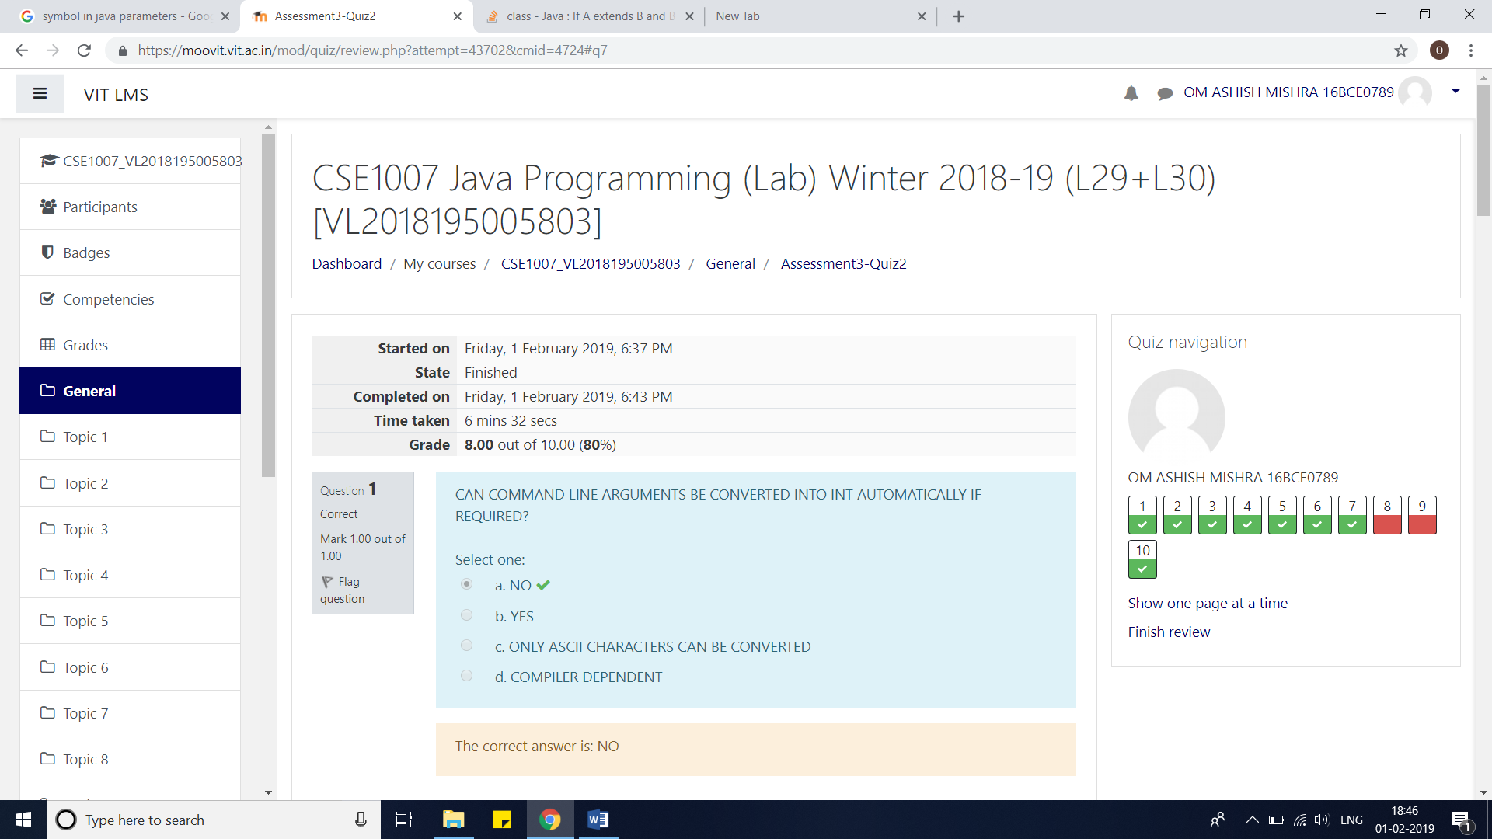

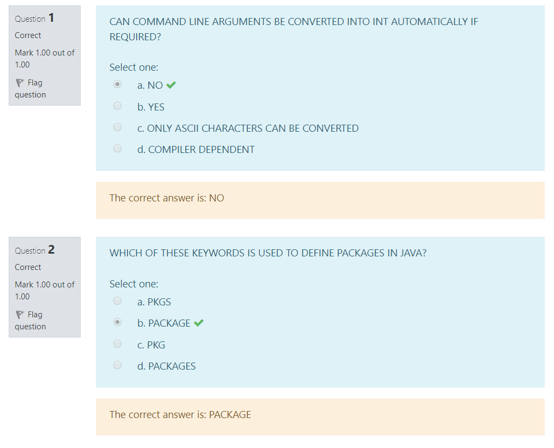

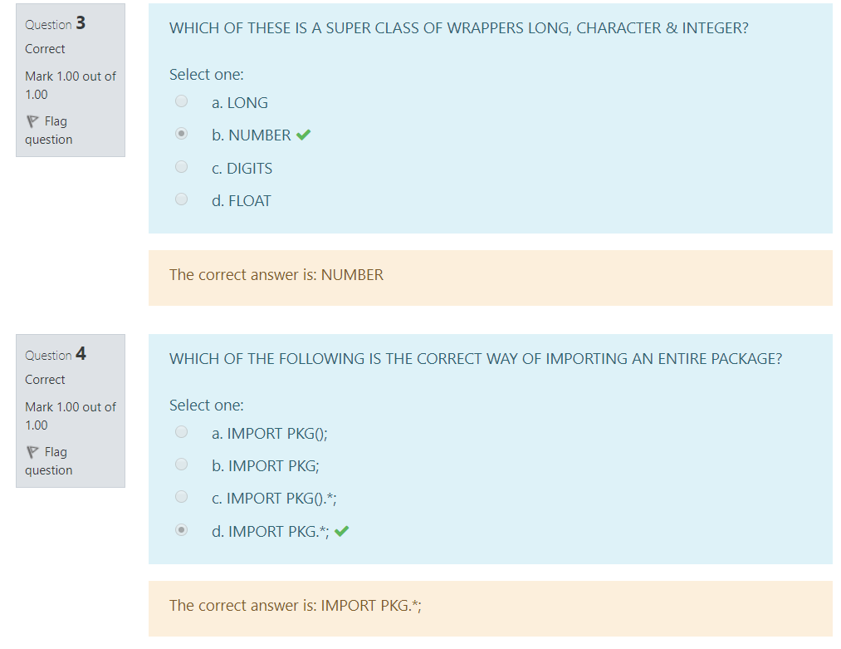

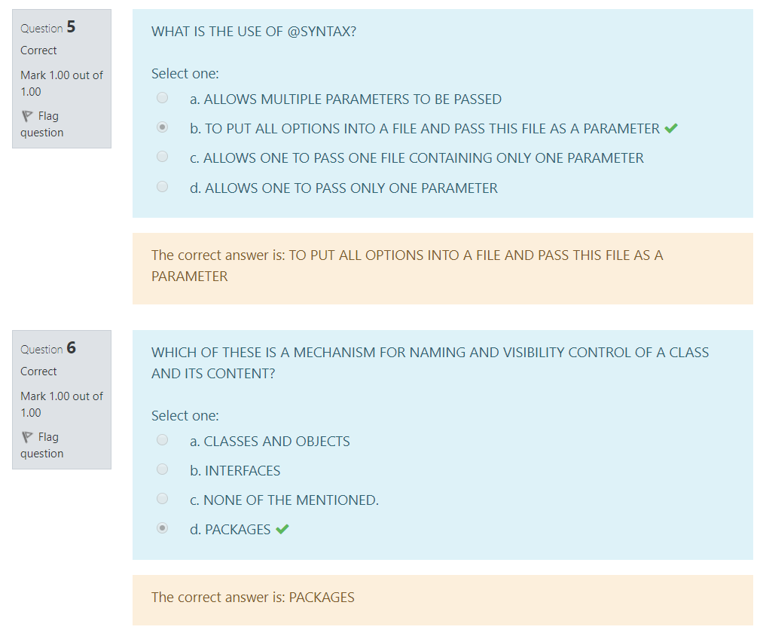

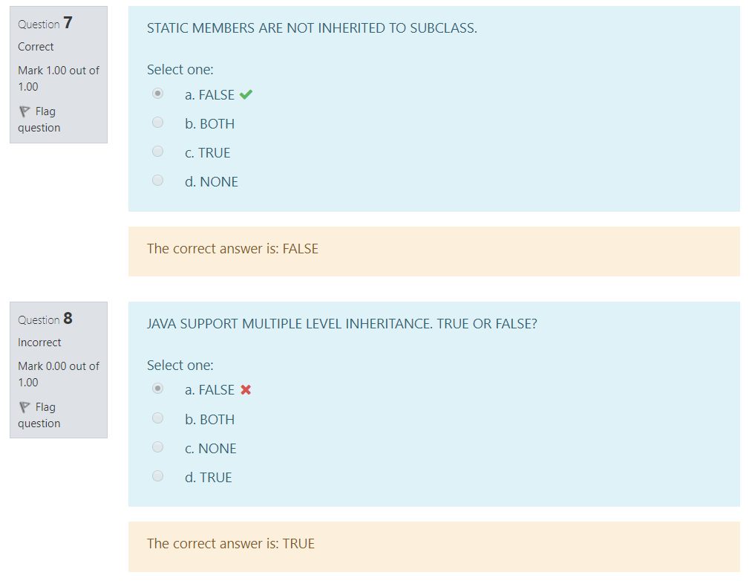

Multiple or multilevel is not clearly stated. Therefore I guessed to be a multiple inheritance and answer came out to be multilevel inheritance.

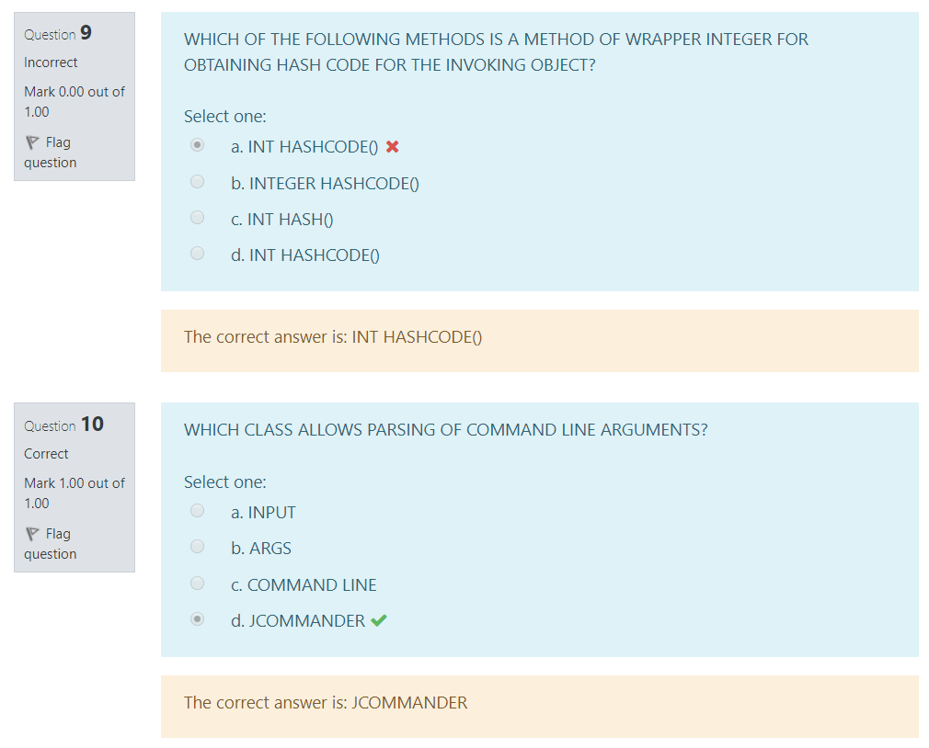

The Option A and D are the same and it shows wrong.

